Question 3:

Manually configure static IPs on the client devices(like Pc or your mobile phone) and verify connectivity using ping.

Approach:

Now we are using 2 pc connected to same router. One is the local machine and another is the Virtual Machine

First let’s check the static IP of the virtual machine

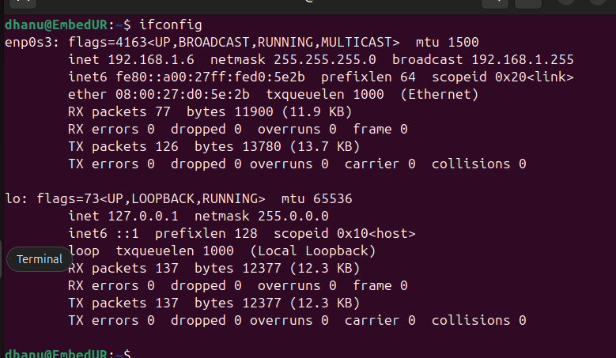

As we see the static IP is 192.168.1.6

Now we will check static ip of local machine.

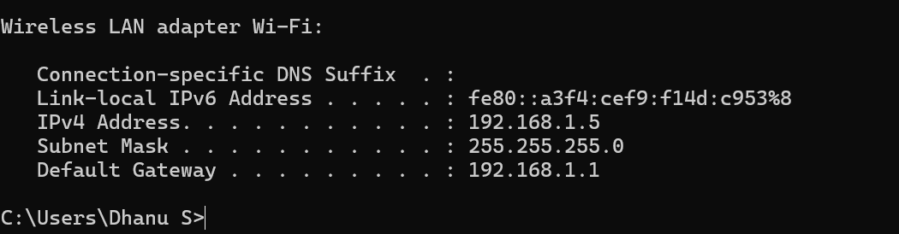

The static IP comes out to be 192.168.1.5

Now from local machine we are trying to ping the Virtual Machine.

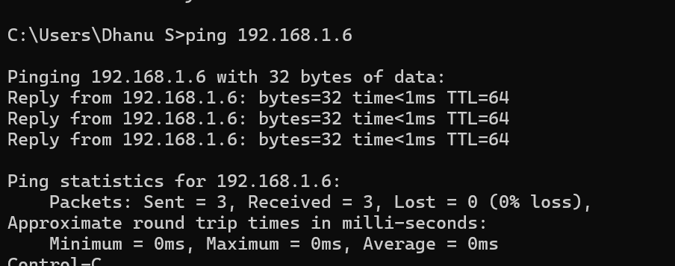

The ping was successful. Which says that the flow is good.

Now we are changing the Static IP of virtual Machine by the below command



Once done restart the network manager to apply the changes ad cross check the ip address.

Note: All ip should be in same class and sub class

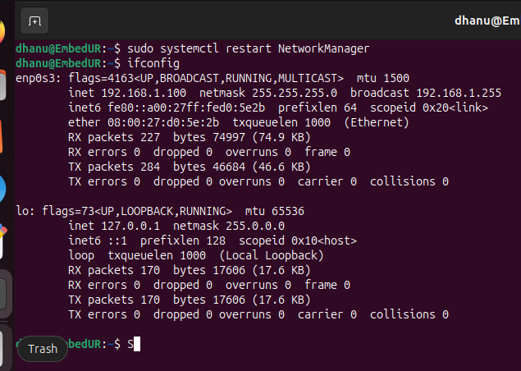

Once done, now try to ping the virtual machine with new static IP that we assigned.

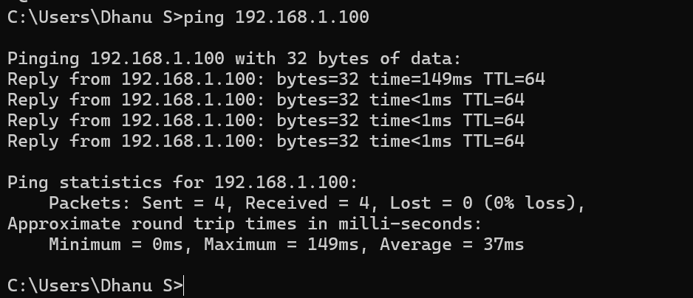

We are successfully able to ping the virtual machine with the new static IP address